AMAZON SIMPLE QUEUE SERVICE
Amazon Simple Queue Service (SQS) is a fully managed message queuing service used to decouple distributed applications.
It acts as a temporary storage area for messages between applications.
Why Do We Use SQS?
SQS helps solve:
- application dependency issues
- traffic spikes
- asynchronous processing
- reliability problems

Use Case : An e-commerce website receives thousands of customer orders.
If the backend database becomes slow or overloaded:
- orders may fail
- users may see errors
- system may crash
To avoid this, we use Amazon SQS.
Create SQS Queue
Click create queue give queue name
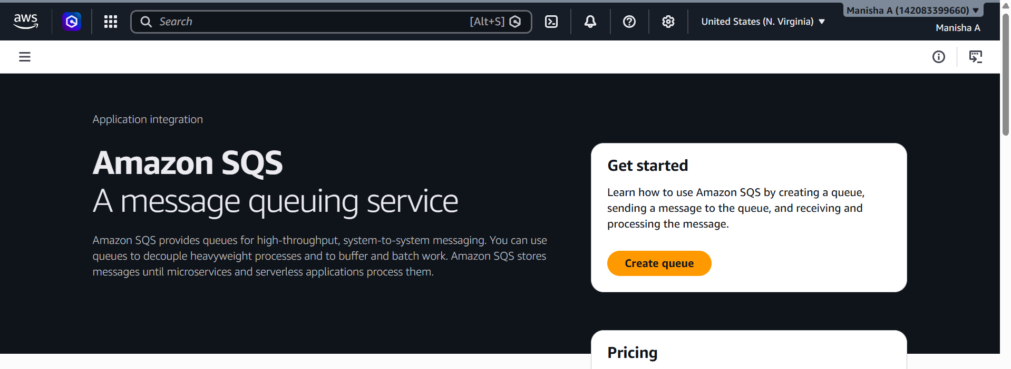
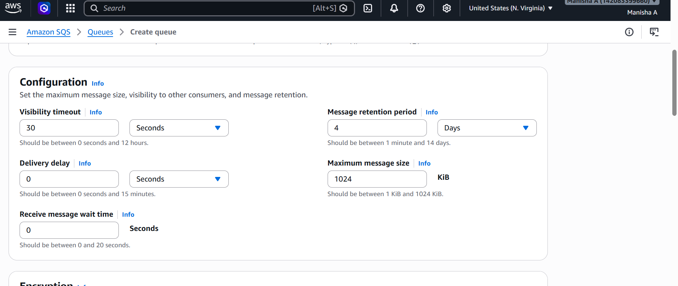
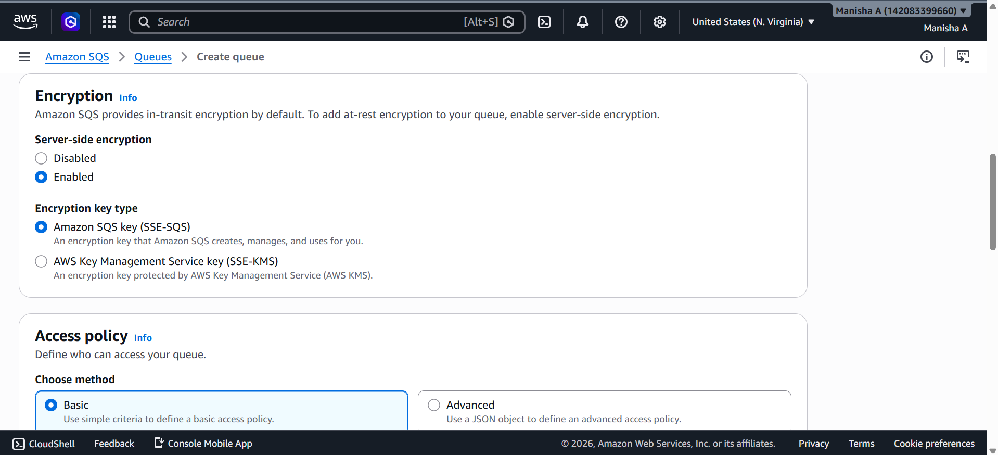
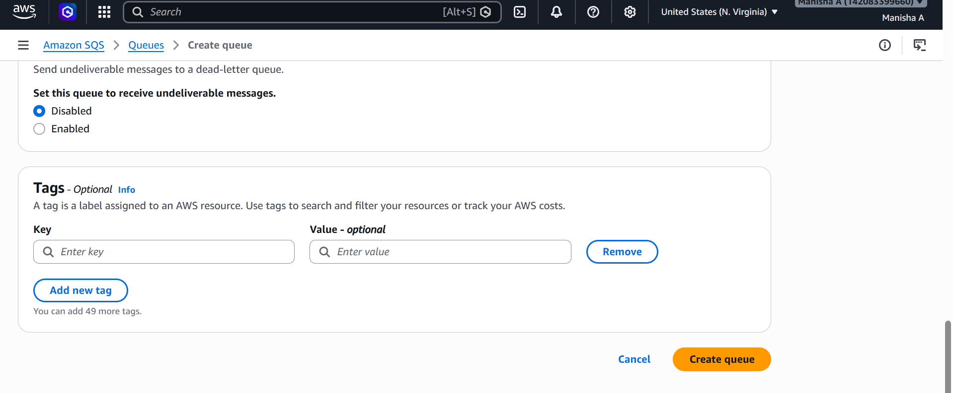
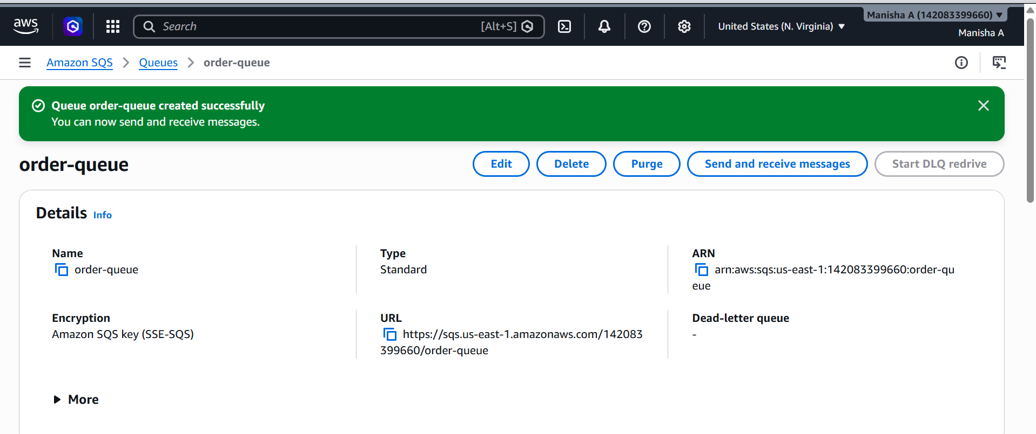
Send Order Message
Click on send and order messages write json script in message body send message

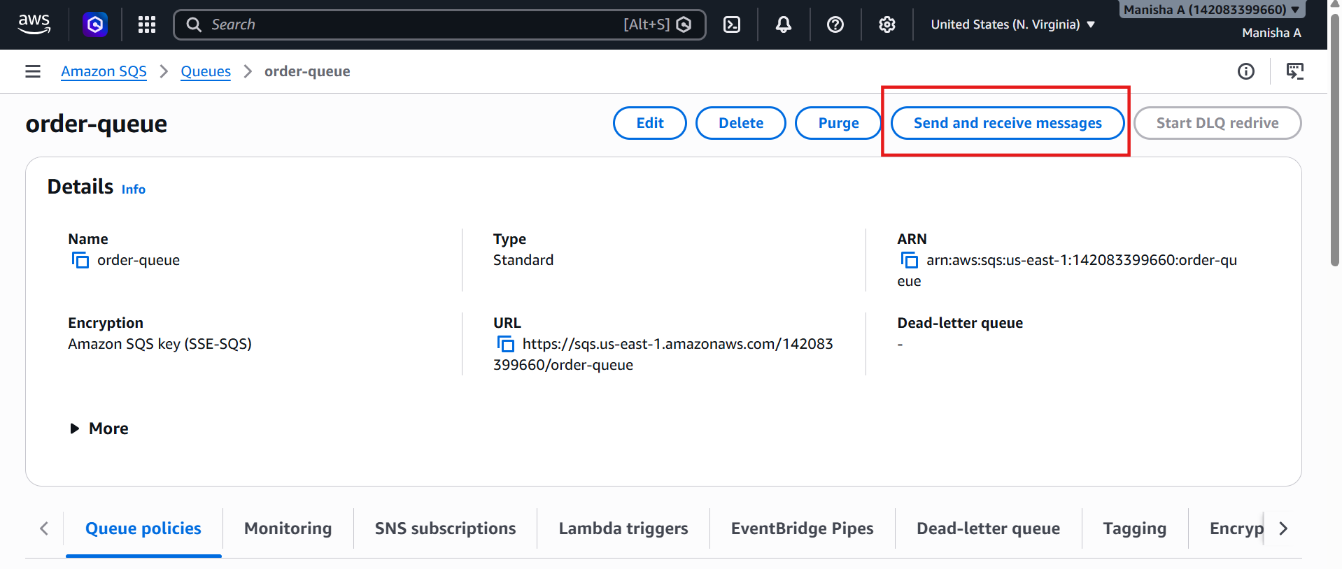
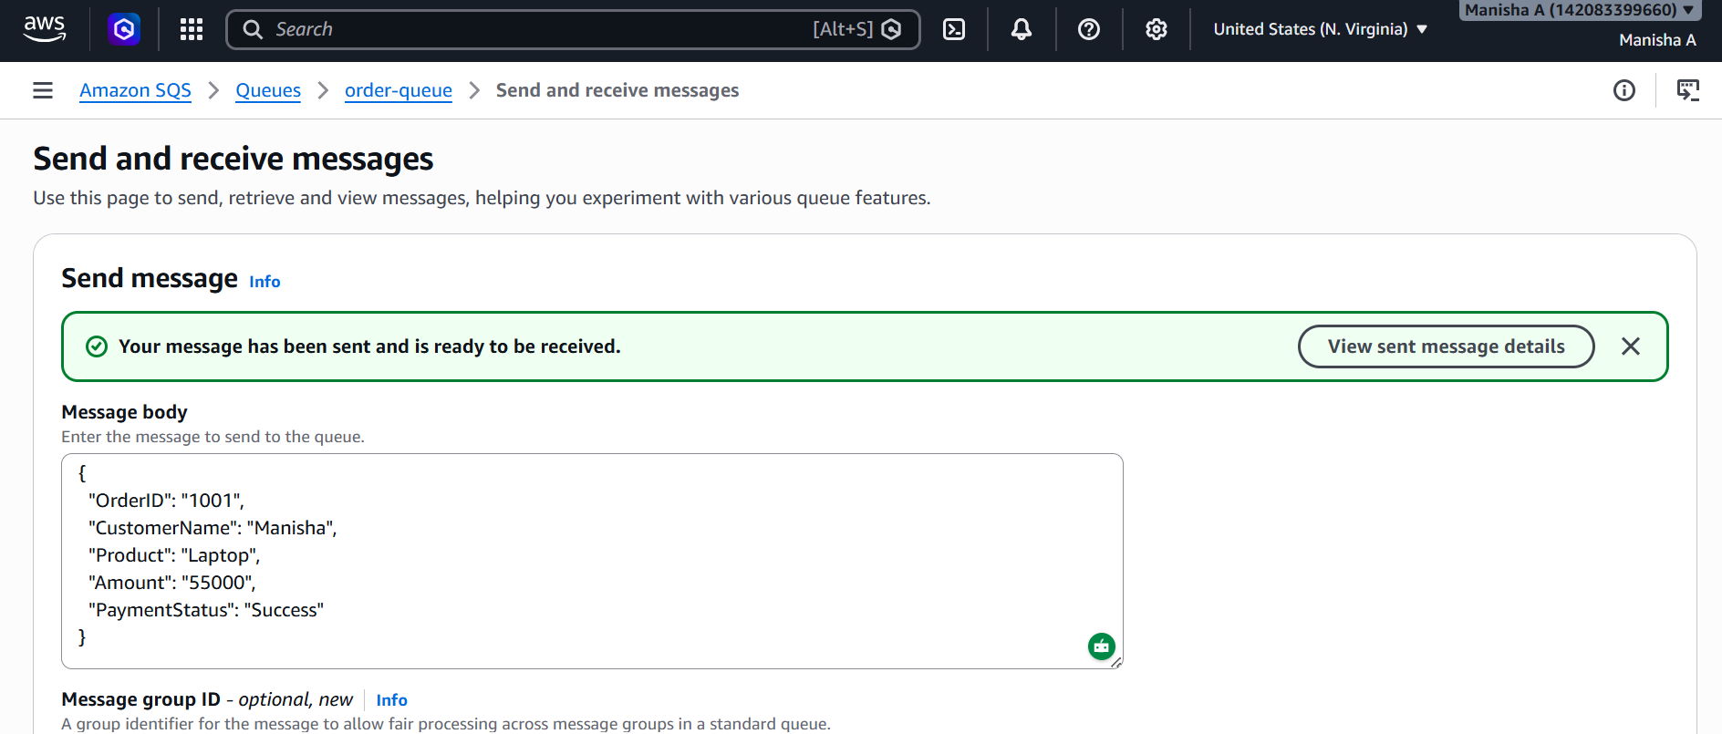
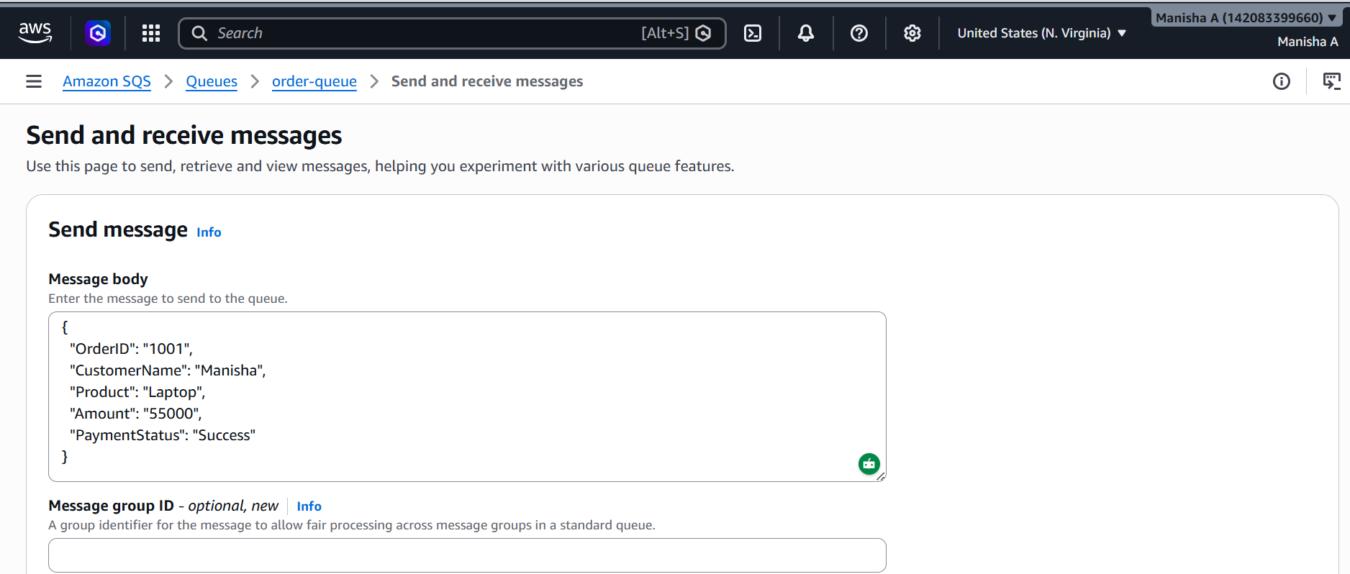
Go to receive messages click pull for messages
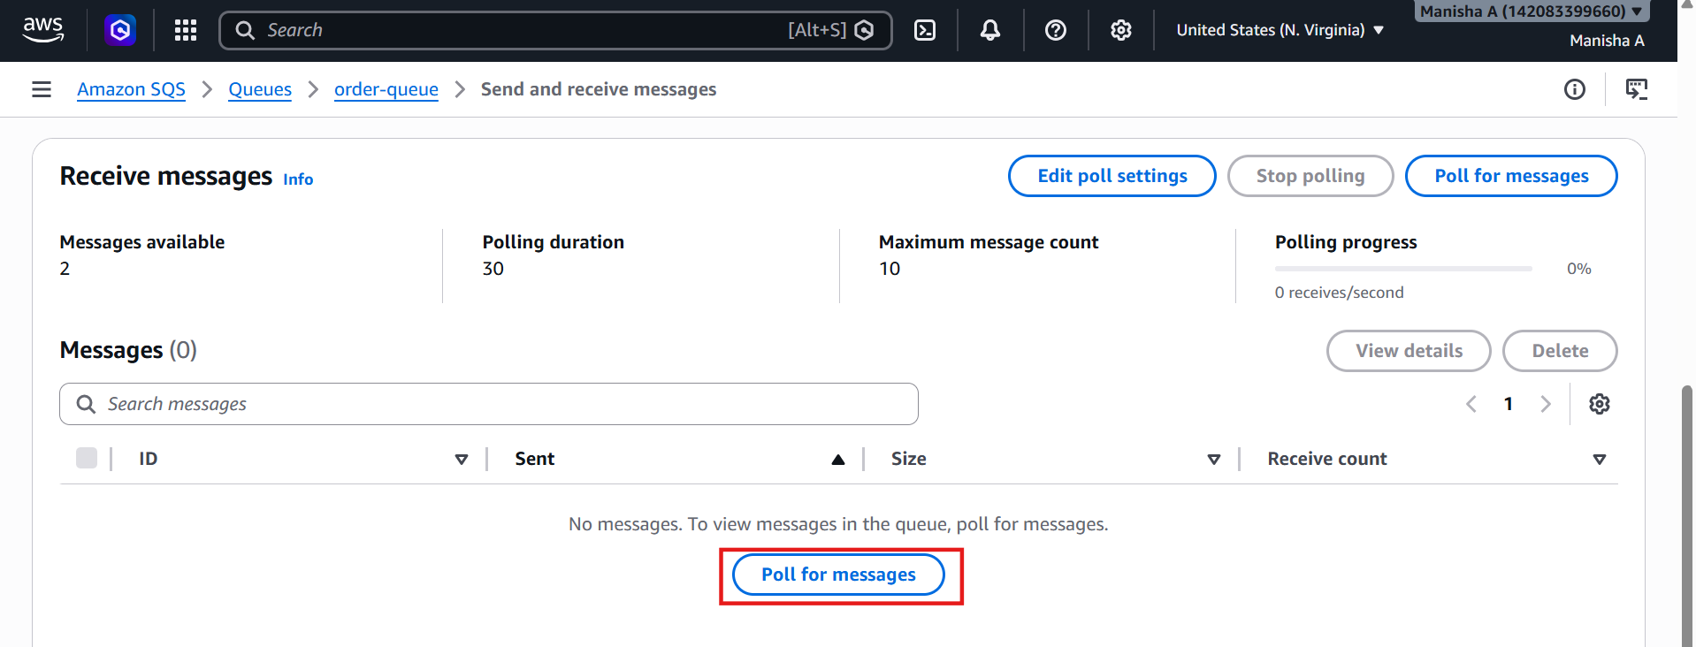
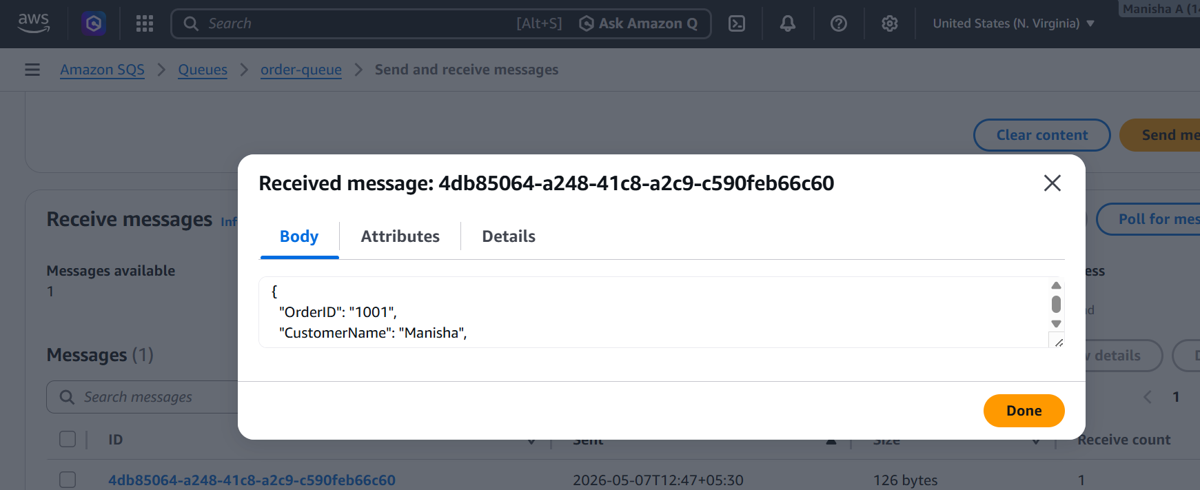
Monitor logs
